 | INSTITUCIÓN EDUCATIVA LOPERENA GARUPAL  “Superación académica, disciplina y amor al colegio”  Valledupar, Cesar | 
 | TALLER SEMANAL PARA TRABAJO NO PRESENCIAL BACHILLERATO
DOCENTE | Cinttia Acosta Márquez | CONTACT | 3178531724
GRADO | Decimo | GRUPO | 01-02-03
GUÍA | 1 | TALLER | Primer periodo.
ASIGNATURA | Inglés. | TEMA | Simple tenses.
DBA | Intercambia información sobre temas del entorno escolar y de interés general en una conversación.
SIMPLES TENSES.
"Simple tense" is a category of verb tense. It covers the simple past tense, the simple present tense, and the simple future tense.  The three simple tenses express facts or habitual activities. Unlike the other tenses, the simple tenses describe actions without specifically stating whether the actions are completed or ongoing. | El "tiempo simple" es una categoría de tiempo verbal. Cubre el tiempo pasado simple, el tiempo presente simple y el tiempo futuro simple.  Los tres tiempos simples expresan hechos o actividades habituales. A diferencia de los otros tiempos, los tiempos simples describen acciones sin indicar específicamente si las acciones están completadas o en curso.

The Simple Past Tense. | The Simple Present Tense. | The Simple Future Tense.
The simple past tense describes a completed activity that happened in the past. In other words, the activity started in the past and ended in the past.  For example:  - I went.  - He saw.  Example: I cleaned the window. | The simple present tense is a complex tense. It is used:  (1) To describe facts and habits Exam: Lee loves pies. (Fact)  (2) To describe scheduled events in the future. Exam: The plane arrives at 7 o'clock.  (3) To tell stories (particularly jokes) Exam: A skeleton walks into a bar and says "Give me a beer and a mop."  Example: I clean the window. | The simple future tense is used for an action that will occur in the future.  For example:  - I will go.  - He will see.  Example: I will clean the window.
GRAMMAR
The Simple Past Tense.  [base form of the verb] + ED  Example:  - They jumped. | The Simple Present Tense.  [base form of the verb] or (he, she, or it) + S  Example:  - We jump.  - He jumps. | The Simple Future Tense.  Will + base form of the verb  Example:  - He will jump.

ACTIVITY IN CLASS
A. Put in the verbs in brackets into the gaps.

1) They __________a nice garden. (to have)
2) She ____________to lose weight. (to try)
3) Hawaii ______________in the Pacific Ocean. (to be)
4) My aunt often_______________queues. (to jump)
5) Ally ____________his handwriting. (can/not/to read)
6) We sometimes _____________around the shops. (to look)
7) I _____________travelling. (to enjoy)
8) Water_________________ when it ________________ (to expand) (to freeze)
9) David usually___________________French on the telephone. (to speak)
10) Stan ____________ Pat and Steve ____________ rather popular. (to gather) (to be)
WORKSHEET
Fill in the words into the crossword. Form the 3rd person singular of the Simple Present and write into the grid.
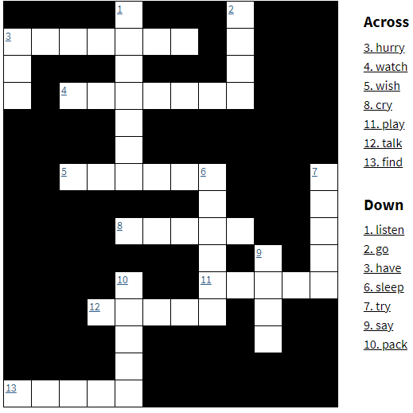

HOMEWORK
Fill in the will - future of the words below.
have – go – meet – visit – walk – have – buy – not be – have
Tomorrow I ___________my friend George. We _________to the movies and then we __________our dinner at the new fast – food place. In the afternoon we _____________ George's uncle and play table tennis in his garden. Then we _________around in the shopping mall where we ___________a look at the shops. Maybe I __________new jeans. We ____________ back before 6 o'clock. I think we ______________a great day.

Fill in the correct simple past forms.
arrange • bring • choose • decide • find • get • go • say • start
Last month Jenny, Nick and Ben _____________ to do a project together. They __________Cornwall. First Jenny ______________ a travel agency and ______________ some brochures. Nick and Ben ___________ some interesting books in the library. Then they _____________work. A week later they _______________ all their material to school and ______________ on a poster. ‘Your presentation is interesting, ____________ Miss Hunt.
RECOMENDACIONES
- El diccionario es una herramienta fundamental en el aprendizaje de cualquier lengua extranjera, por lo tanto, usted debe buscar todas las palabras desconocidas que encuentren en cada guía de trabajo y elaborar un glosario para retroalimentar cuando se requiera.
- Ve al siguiente link si necesitas comprender mejor https://www.youtube.com/watch?v=69lzkfvFUqQ
- Copia la información en tu libreta (con los cuadros). Las actividades son de estricto cumplimiento. De tu dedicación depende el éxito de tu trabajo.
- Las actividades deben ser enviadas al CLASSROOM. Clave de acceso: 3mnhsx3 y/o enviarlas al
correo institucional pcinttiaacosta@ieloperenagarupal.edu.co Mi número de contacto: 3178531724.

